- Lemma. 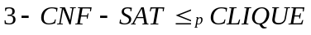
Let 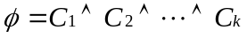 be a Boolean formula in 3-CNF with k clauses, where 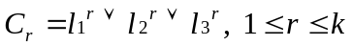.
For each clause C_{r}, place a triple of vertices V₁^{r}, V₂^{r}, V₃^{r}.
Regarding edges, 2 vertices 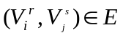 iff
1. 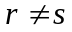
2. l_{i}^{r} and l_{j}^{s} are consistent, i.e. l_{i}^{r} is not the negation of l_{j}^{s}.

- See Fig 36.12 for an example
This graph can be computed in polynomial time (why?)

- To show that this transformation of ψ into G is indeed a reduction, we show

  - Supposeψ has a satisfying assignment. Therefore, each clauses C_{i} contains at least one literal l_{i}^{r} that is assigned 1. Besides, any pair of such literals must be consistent. Therefore, pick one such literal from each clause yields a set of V’ of k vertices and V’ must be a clique.

  - Suppose G has a clique V’ of size k. V’ contains exactly one vertex per triple. Assigning 1 to each literal l_{i}^{r} s.t. 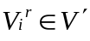 yields a satisfying assignment.

